DSP Education Kit
Getting Started Guide
Setting up STM32F7 Discovery Kit with Arm-MDK
Issue 1.0

Contents
1 Introduction 1
1.1 Lab Overview 1
2 Requirements 1
2.1 Software Requirements 1
2.2 Hardware Requirements 2
2.2.1 Overview of STM32F746G Discovery board 2
3 Setting Up Keil MDK-Arm Project 3
3.1 Download and Install Keil MDK-Arm 3
3.2 Install the STLink USB Driver 4
3.3 Running the Project 4
3.3.1 Expected results 5

Introduction

Lab Overview
In the labs for this course, we will use the STM32F7 Discovery Kit to practice digital signal processing concepts and explore some of their applications using advanced hardware.
Some tasks in the labs for this course require you to run example programs on the STM32F7 Discovery Kit. Therefore, you will need to install a suitable development environment on a host PC. This document describes the steps necessary to install and configure the Keil MDK-Arm IDE for use with the STM32F7 hardware platform and to start running the example programs.
The instructions in this guide assume that all software is installed in the default locations or at the locations specified explicitly in this document. It is beyond the scope of these instructions to anticipate other possible working configurations. It is quite possible that a working configuration may be achieved by different means than described here, but the procedures described in this document have been tested successfully on Windows 11.

Requirements

Software Requirements
The following table is a list of required software tools that you need for the labs.
Software | Website | Version¹
Keil MDK-Arm | https://www.keil.com/update/rvmdk.asp | v5.41 or the latest version  Note: A licensed version of Keil-MDK is needed due to the code size in the programs for this lab. For more information, see https://www2.keil.com/mdk5/selector.
MATLAB | https://mathworks.com/downloads/ | R2019a or the latest version
GoldWave | https://www.goldwave.com/release.php | v6.41 or the latest version
Example programs and ancillary files | Provided with labs | Note: The example programs used in this lab have been tested using the STM32Cube MCU Package for STM32F7 Series (v1.17.0).
Table 1: Software tools and versions
¹ The software versions listed here are versions that we have verified to be working with our labs. You can use the latest available (and most stable) versions of the software if backward and forward compatibility is supported.

Hardware Requirements
You will need the STM32F746G Discovery board for these labs.
Hardware | Additional Information
STM32F746G Discovery board | This is the board that will be used to run the programs in the lab exercises.  In some optional exercises, you will need two Discovery boards.  The board can be found at: https://www.st.com/en/evaluation-tools/32f746gdiscovery.html
Oscilloscope | This will be necessary for several exercises, with various uses such as time measurements of output signals.
Signal Generator | Necessary for some exercises that require a generated input signal.
BNC T-Piece | Used to split the signal generator output that will be necessary in some exercises.
Earphones/Headphones with a microphone | Used in some exercises to listen to signals/input sound signals.
3.5 mm Audio Jack(s) | Used to connect various peripherals to the Discovery board.
Table 2: Hardware requirements

Overview of STM32F746G Discovery board
The STM32F746G Discovery board features a Cirrus Logic WM8994 stereo audio codec, which is accessed via I2C for control and I2S, using the STM32F746G microcontroller’s serial audio interface (SAI) peripheral, for data. Analog input and output signals are accessible via two three-pole (TRS) 3.5 mm jack sockets (LINE IN (CN11) and HEADPHONE OUT (CN10)).
As configured for these exercises, the WM8994 converts an analog input signal into 16-bit signed integer sample values, and the DAC converts 16-bit signed integer sample values into an analog output signal.
Additionally, the WM8994 has a digital microphone interface, and the STM32F746G Discovery board provides two MEMS microphones as input devices.
Some of the hardware features of the STM32F746G Discovery board are highlighted in Figure 1.
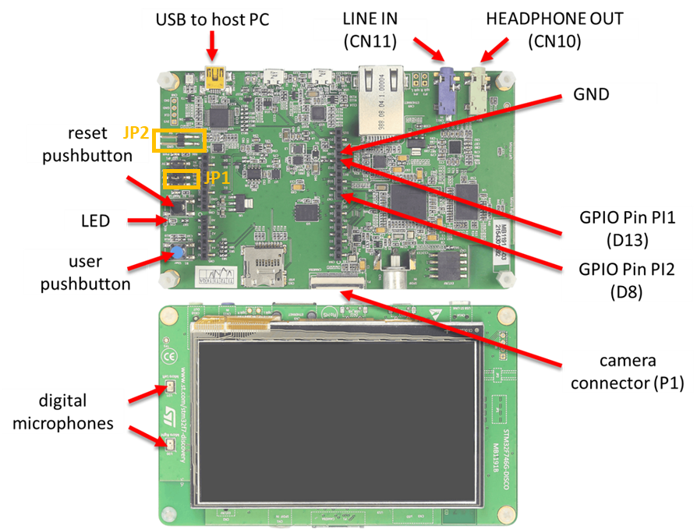
Figure 1: STM32F746G Discovery board

Note: For this course lab exercises, JP1 should be set to “5V link USB + 5V.” JP2 should be left open.

Setting Up Keil MDK-Arm Project

Download and Install Keil MDK-Arm
Keil MDK-Arm is the development environment from which executable code will be built and downloaded to the Arm Cortex-M4 processor on the Pioneer Kit.

Due to the size of the example programs in the labs, you will need a license for Keil MDK-Arm. You cannot run the example programs using the free version, which limits the code size.

To set up Keil MDK-Arm, follow these instructions:

- Download MDK-Arm from the URL link shown in Software requirements.
- Install Keil MDK-Arm by running the downloaded executable file (e.g., MDK523.exe) and following the instructions. The files downloaded will, by default, be installed at C:\Keil_v5.
- Download the released zip file from the DSP-Edkits-Labs repository and unzip it.
- Open the Project.uvprojx file in the Projects/STM32746G-Discovery/<Project-Directory>/MDK-ARM directory.
- Copy Project_Template(STM32G746G) directory and use it as your project template.

Install the STLink USB Driver
The STLink USB driver enables communication using USB between Keil MDK-Arm and the STM32F407 Discovery board.
The STLink USB driver can be found at C:\Users\<username>\AppData\Local\Keil_v5\ARM\STLink\USBDriver\. Execute either dpinst_amd64 (64-bit version) or dpinst_x86 (32-bit version).

Running the Project
To ensure successful installation and setup of the Arm Keil MDK for the DSP lab, we shall run the project file that is provided with the DSP Education Kit by following these steps:
- Ensure you are using a licensed version of Arm Keil MDK. Due to the code size, compiling the code will not work on the Arm Keil MDK Lite version.
- Navigate to the DSP-Edkits-Labs\Getting_Started\Projects\STM32746G-Discovery\Getting_Started\MDK-ARM folder and double-click on the Project.uvprojx file. You should see a project structure similar to that shown in Figure 4. The project should contain the example file stm32f7_sine_lut.c, which contains the main() function.
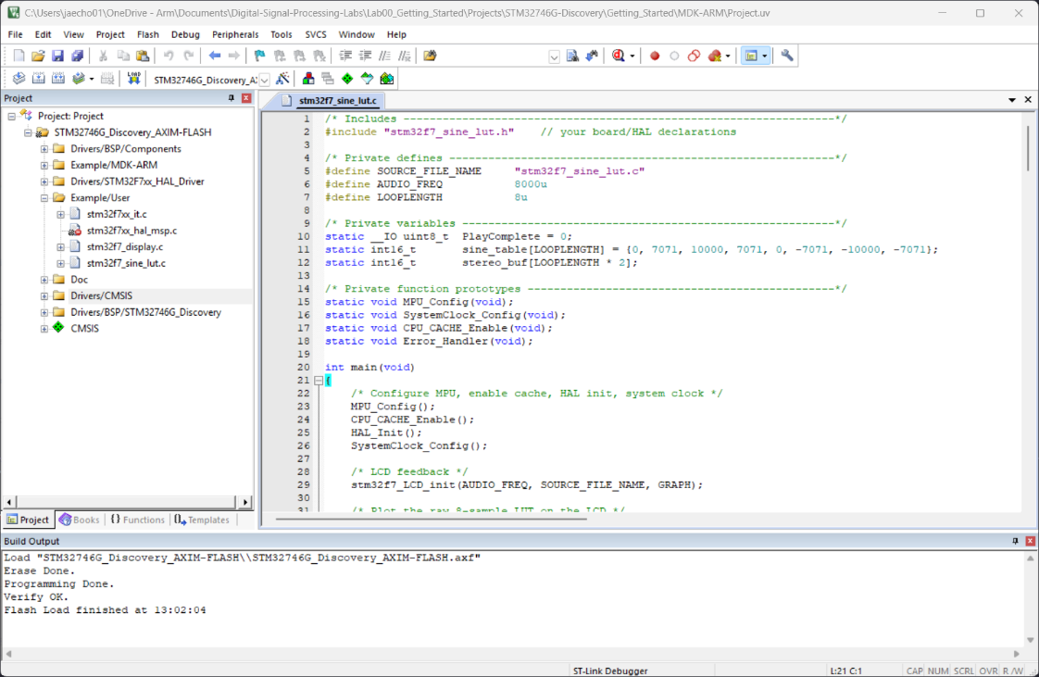
Figure 4: Screenshot of MDK-Arm showing the project
- Connect the STM32F746 Discovery board to the host PC using a USB A to USB Mini B cable.
- Plug the headphones into the output audio jack socket (CN10) on the board.
- Build the project by selecting the Project > Build target or by clicking on the Build toolbar button .
- Ensure that the correct debugger is selected in Keil MDK by following these steps:
  - Select Project > Options for Target.
  - Open the Debug tab in the Options for Target window.
  - On the right side of the Debug tab, select the driver for the debugger on the Use dropdown menu.
  - Select ST-Link Debugger.
- After successfully building the project with no errors, switch to the debugger mode (and download the executable code into flash memory) by clicking on the Start/Stop Debug Session toolbar button .
- Once the Debugger View has appeared, click on the Run toolbar button as shown in the following figure:

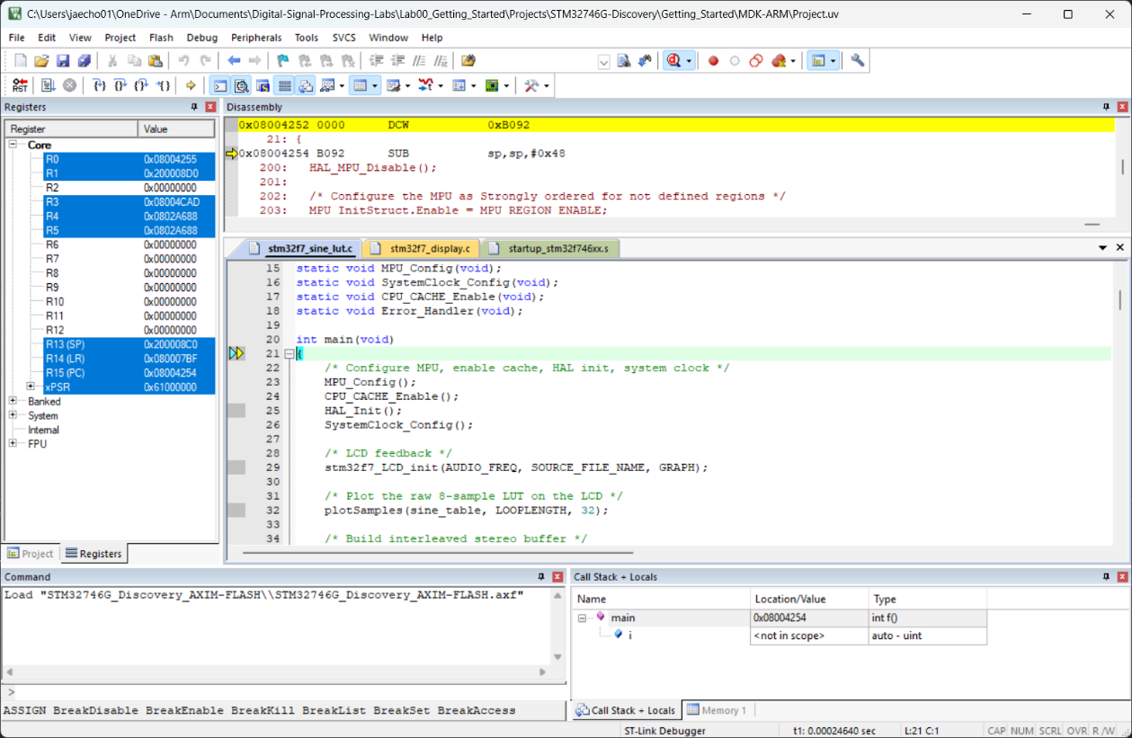
Figure 5: Snapshot of debugger view

Expected results
Once the program is running, you should see a start screen on the LCD on the board showing the program name as shown in the following figure.
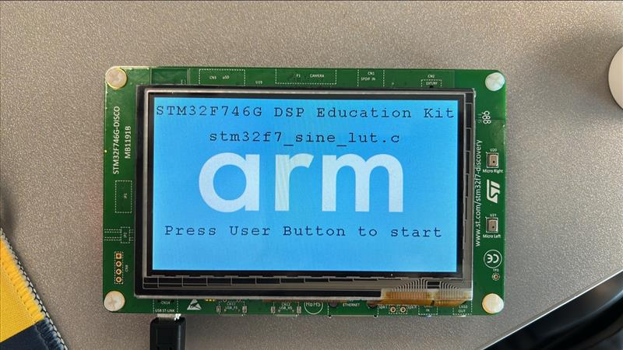
Figure 6: Start screen on LCD
Press the User Button shown in Figure 1. You should get a 1 kHz tone output on the HEADPHONE OUT socket on the Discovery board and the following display.
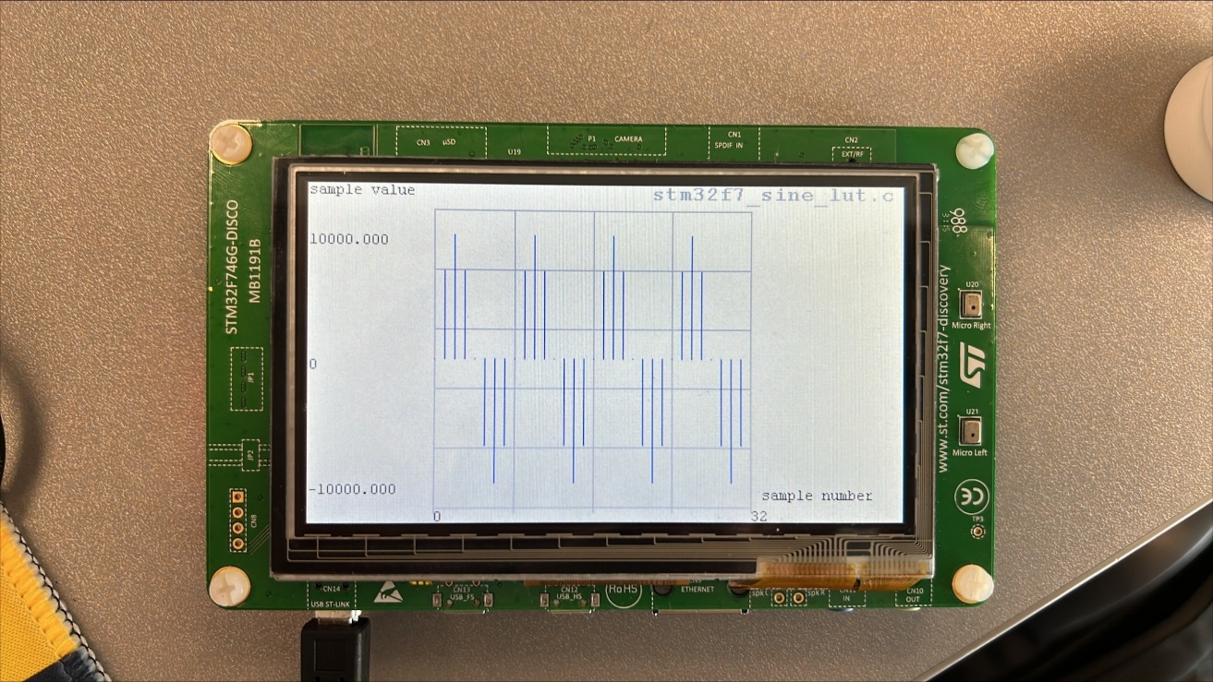
Figure 7: 1 kHz tone display on LCD

